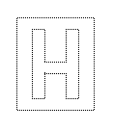 | TEMASEK JUNIOR COLLEGE, SINGAPORE  Preliminary Examination  Higher 2
MATHEMATICS |  |  | 9740/02
Paper 2 |  |  | 19 September 2012
Additional Materials: | Answer paper |  | 3 hours
 | List of Formula (MF15)
READ THESE INSTRUCTIONS FIRST
Write your Name and Civics Group on all the work you hand in.
Write in dark blue or black pen on both sides of the paper.
You may use a soft pencil for any diagrams or graphs.
Do not use staples, paper clips, highlighters, glue or correction fluid.
Answer all questions.
Give non-exact numerical answers correct to 3 significant figures, or 1 decimal place in the case of angles in degrees, unless a different level of accuracy is specified in the question.
You are expected to use a graphic calculator.
Unsupported answers from a graphic calculator are allowed unless a question specifically states otherwise.
Where unsupported answers from a graphic calculator are not allowed in a question, you are required to present the mathematical steps using mathematical notations and not calculator commands.
You are reminded of the need for clear presentation in your answers.

At the end of the examination, fasten all your work securely together.
The number of marks is given in brackets [ ] at the end of each question or part question.



This document consists of 7 printed pages.

[Turn Over
Section A: Pure Mathematics [40 marks]

1 A curve C is defined by the parametric equations
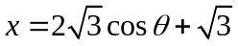, 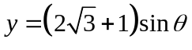 where 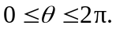
(i) Find 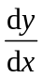in terms of . [2]
(ii) Show that the Cartesian equation of the curve C is 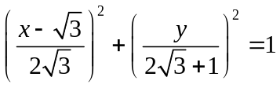. Hence or otherwise, sketch the graph of C, indicating clearly the x-intercepts in exact form. [3]

(iii) The point P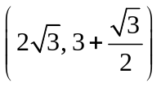 lies on curve C. The region R is bounded by the curve C for 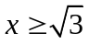, the x-axis and the line segment joining the points P and 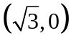.
Show that the area of R is 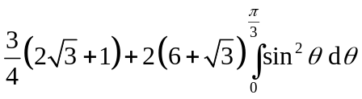 units². [4]

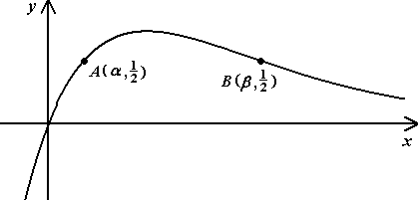
2

The diagram above shows the curve of 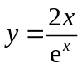. Two points A and B on the curve have coordinates (α, 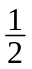) and (β, ) respectively.
A sequence of real numbers 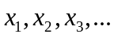satisfies the recurrence relation
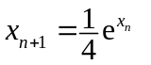 for n ≥ 1.
(i) Show algebraically that if the sequence converges, then it converges to either α or β. [3]
(ii) Show that 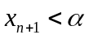 if 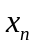< α . [2]
(iii) Show that 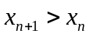 if < α . [2]
(iv) Explain briefly how the results in (ii) and (iii) may be used to deduce that the sequence converges to α when 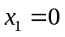. [2]

3 The function f is defined by
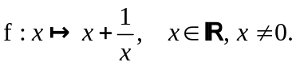
(i) Sketch the graph of 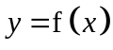, showing clearly the coordinates of the stationary points and the equations of asymptotes, if any. [2]
(ii) Given that 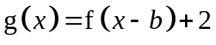 where 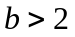, state a sequence of transformations which transform to 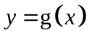. [2]
Sketch the graph of , showing clearly the coordinates of the stationary points and the equations of asymptotes, if any. [2]
On a separate diagram, sketch 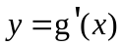 and solve the inequality
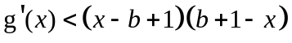. [5]

4 (i) Find the roots of the equation 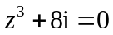, giving them in cartesian form a + ib, where a and b are exact real numbers. [3]
(ii) The roots of the equation 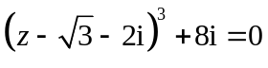 are 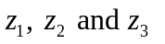such that 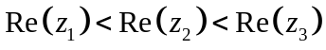. Hence find in cartesian form a + ib, where a and b are exact real numbers. [2]
(iii) Show on an Argand diagram. [1]
(iv) Explain why the locus of all points z such that 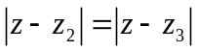 passes through the point representing 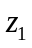. Draw this locus on your Argand diagram and find the minimum value of 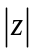. [5]

[Turn Over
Section B: Statistics [60 marks]
5 2 men and 5 women go to a restaurant for a meal. They choose an outdoor round table with 7 seats. Find the number of ways the group can be seated if
(i) the two men are not seated next to each other, [2]
(ii) one of the women, Mary, is to be seated between the two men. [2]

Before their orders arrive, they request to shift to a table in the 'non-smoking' section of the restaurant. They are then given a round table with 10 seats.
Find the number of ways they can be seated if
(iii) the empty seats are adjacent to each other, [2]
(iv) none of the empty seats are adjacent to each other and there must be more than 1 person between any two empty seats. [2]

6 Eighteen numbers are arranged in three groups of six as follows:
Group A: 0, 2, 2, 2, 2, 9
Group B: 3, 3, 3, 7, 7, 16
Group C: 1, 1, 1, 1, 6, 6
One number is drawn at random from each group. Let a, b and denote the number drawn from groups A, B and C respectively.
Event X is defined as "b is greater than the sum of a and c".
Event Y is defined as "b is greater than both a and c".
(i) Show that 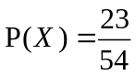. [3]
(ii) Find 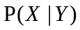. [4]

A game is played with a biased coin where the probability of getting a head is . A player first flips a coin. If the coin shows a Head, the player draws a number from Group B and the score is the number drawn. If the coin shows a Tail, the player draws a number from Group A and C each, and the score is the sum of the numbers drawn. If the probability of obtaining a score of 3 is 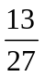, find the value of p . [2]

7 Two friends, Bob and Patrick, meet up each week at a swimming complex for a 200m freestyle friendly match. The time (in seconds) taken by Bob to complete a 200m freestyle swim follows a normal distribution with mean 152 and standard deviation 2.2 while the corresponding time taken by Patrick is also normally distributed with mean 156 and standard deviation 3.0.

(i) Show that the probability of Patrick beating Bob in a 200m freestyle match is 0.141, correct to 3 decimal places. [1]
(ii) Find the probability that the total time taken by Bob to complete a 200m freestyle swim on two different occasions is less than twice the time taken by Patrick to complete a 200m freestyle swim on one occasion by less than 5 seconds. [4]

Bob and Patrick maintained their weekly swimming matches for a total of k weeks, where 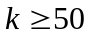. Use a suitable approximation to find the least value of k such that the probability of Patrick beating Bob on fewer than four occasions is not larger than 5%. [5]

8 An online web survey company wishes to find out the number of hours spent per week, on average, by a typical teenager on Facebook. A survey was conducted on a random sample of 70 teenagers and the time spent per week, x hrs, was recorded and summarized:
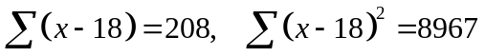

(i) Find, correct to 1 decimal place, the unbiased estimates of the population mean and variance. [2]
(ii) It is claimed that a typical teenager spends an average of 18 hours a week on Facebook. Test, at the 5% level of significance, whether the population mean weekly time differs from 18 hours. [4]
(iii) Another independent online survey company claims however, that the population mean weekly time spent on Facebook by teenagers actually exceeds μ₀, where μ₀ is a constant.
Use the earlier sample to determine, correct to 1 decimal place, the least value of μ₀ in order for the new claim not to be valid at 5% level of significance. [4]

[Turn Over
9 Records show that one in every 6 students who go to the Career Fair for junior college students will stop by the Police Force’s booth to make enquiries.

A class of 25 students visit the Career Fair. Show that the probability that fewer than 10 students make enquiries at the Police Force’s booth is 0.99526. [2]

60 classes, each consisting of 25 students, visit the Career Fair.
(i) Find the probability that the average number of students per class who make enquiries at the Police Force’s booth is neither fewer than 4 nor greater than 6. [3]
(ii) Using a suitable approximation, find the probability that 58 classes have fewer than 10 students making enquiries at the Police Force’s booth. [4]

To gather students' feedback on the Fair, a member of the Career Fair Committee decides to interview 20 male and 30 female students from the student population.
Name the sampling method used and give one disadvantage of this sampling method. [2]

10 A study was carried out to investigate possible links between the weights of hens (x kg) and their eggs (y g). A sample of 15 hens was chosen at random and the weights of these hens and their eggs were noted. The scatter diagram and the summarized information for the sample are shown below. The linear product moment coefficient was also computed and found to be 0.200.

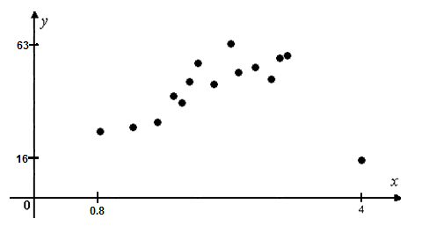
By referring to the scatter diagram and the given value of the linear product moment correlation coefficient, comment on the appropriateness of the linear model. [1]

n | 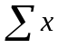 | 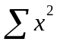 | 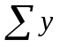 | 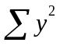 | 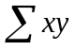
15 | 33.9 | 85.99 | 690 | 34432 | 1591.2

One of the points, (4, 16), was identified as an outlier and removed.

(i) For the remaining sample of size 14, recalculate the values in the table above and determine the value of the linear product moment correlation coefficient. Show your workings clearly. [4]
(ii) Use a suitable regression line to estimate the weight of an egg laid by a hen weighing 2.5 kg. [5]
(iii) Comment on the reliability of your answer. [2]

 END OF PAPER 

